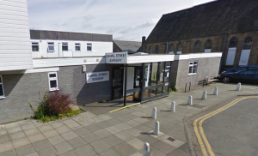
CHapel Street Surgery

newsletter
  - Spring/Summer 2022

In this issue of our newsletter:
- Staff updates
- Who are Sussex Primary Care?
- Surgery Closure Dates
- Birthday Health Reviews
- Improved Access Appointments
- Age appropriate screening
- Common Summer Ailments
- Patient Participation Group

welcome!
Welcome to Chapel Street Surgery’s newsletter. If you have not previously had a chance to read one of our newsletters, the purpose of the newsletter is to update our patients as much as we can about changes within and around the surgery. It also gives us the opportunity to provide information specific to the time of the year.

Staff Updates
As you may all be aware, there is currently a shortage of GP’s nationwide which we appreciate can be very frustrating for you when trying to book an appointment. We would like you to be aware that we are trying our hardest to recruit new GP’s, however we are very lucky to have other healthcare workers here to assist your needs. Our other healthcare workers are:
Sussex Primary Care
Sussex Primary Care came about in response to a need from GP Partners in local practices who were seeking a different future. In 2019 they took on their first two practices and they maintain the local ethos of the practice to respond to patient need.
Sussex Primary Care are here to support GPs and practice staff whilst helping to maintain and strengthen the local identity and clinical leadership of each of their practices.
They are a learning organisation that listens to their team of staff, patients and partners to guide our future.
Sussex Primary Care took on Chapel Street Surgery in August 2020.

Tap here to add a caption
- Paramedic Practitioner who is able to assist with acute illnesses and ailments
- Physiotherapist who is able to advise and assist with new injuries such as sprains and strains and refer to x-ray or MSK if required
- Pharmacy team who are able to assist with any medication queries
- Women’s health nurse who specialises in sexual health, HRT and contraception
- We also have a remote team of Doctors and Advanced Nurse Practitioners who are able to prescribe and refer if necessary
- Change Grow Live who can support with drug and alcohol consumption advice
Our Reception team will signpost you to the most appropriate healthcare professional.
Surgery Closures 2022
- Spring Bank Holiday – Thursday 2nd June 2022
- Platinum Jubilee Bank Holiday – Friday 3rd June 2022
- Staff training 12:30pm-6:30pm – Thursday 30th June 2022
- Summer Bank Holiday – Monday 29th August 2022
- Staff training 12:30-6:30pm – Tuesday 18th October 2022
- Boxing Day – Monday 26th December 2022 (carried over)
- Christmas Day – Tuesday 27th December 2022 (carried over)

Birthday Health reviews
Patients will be contacted by letter or text messages in or just before the month of their birthday inviting them in for their annual health reviews. Please be aware that you may be called in earlier than you are expecting, but this is to streamline our review process which should hopefully reduce visits to the surgery for lots of patients. When you receive your letter, please just ring the surgery and our Reception team will book you an appropriate appointment.

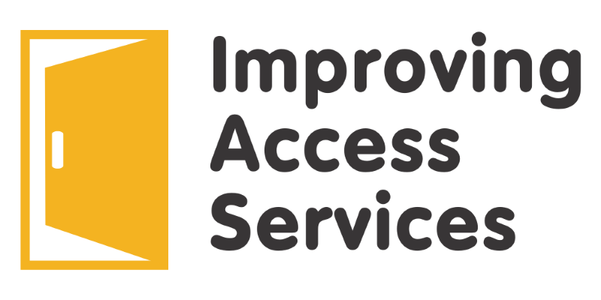

Improving access services
The Improving Access Service (IAS) is dedicated to improving access to primary healthcare services in our area. IAS offer routine, pre-bookable appointments with a GP or nurse which help you to be seen sooner. These appointments are available to book via the Reception team and are held at a different practice on Wednesday evenings and Saturday mornings. There are also telephone appointments available on a Sunday morning in Lewes. For more information, please ask the Reception team.

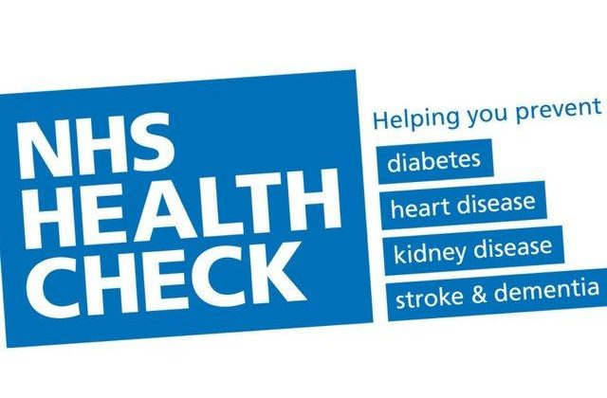

NHS Health checks
The NHS Health Check is a health check-up for adults aged 40-74 with no already known health conditions. It is designed to spot early signs of stroke, kidney disease, heart disease, type 2 diabetes or dementia. As we get older, we have a higher risk of developing one of these conditions. An NHS Health Check helps find ways to lower this risk. To book your NHS Health Check today, please speak to the Reception team who will book you an appropriate appointment.

NHS Screening
Screening is a way of identifying apparently healthy people who may have an increased risk of a particular condition. The NHS offers a range of screening tests to different sections of the population.
The aim is to offer screening to the people who are most likely to benefit from it. For example, some screening test are only offered to newborn babies, while others such as breast screening and abdominal aortic aneurysm screening are only offered to older people.

What types of screening are offered by the NHS?
- Diabetic Eye Screening – from the age of 12, all people with diabetes are offered an annual diabetic eye test to check for early signs of diabetic retinopathy
- Cervical Screening – is offered to all women and people with a cervix aged 25-64 to check the health of cells in the cervix. It is offered every 3 years for those aged 25 to 49, and every 5 years from the ages of 50 to 64.
- Breast Screening – is offered to women aged 50-70 to detect early signs of breast cancer. Women over 70 can self-refer.
- Bowel Cancer Screening – everyone aged 60-74 is offered a bowel cancer screening home test kit every 2 years. If you are 75 or over, you can ask for a kit every 2 years by phoning the free bowel cancer screening helpline on 0800 707 6060
- Abdominal Aortic Aneurysm (AAA) Screening – is offered to men during the screening year (1 April to 31 March) that they turn 65 to detect abdominal aortic aneurysms (a dangerous swelling in the aorta). Men over 65 can self-refer.

What are the benefits of having a screening test?
- Screening can detect a problem early, before you have any symptoms
- Finding out about a problem early can mean that treatment is more effective
- Finding out you have a health problem or an increased chance of a health problem can help people make better informed decisions about their health
- Screening can reduce the change of developing a condition or its complications
- Some deaths from abdominal aortic aneurysms, bowel cancer, breast cancer and cervical cancer can be prevented

If you are eligible and due for screening, please book today!

Common summer ailments
Hayfever
Did you know that if you have hayfever, you do not need to see the GP?
Your Pharmacist can give you advice and suggest the best treatments, like antihistamine drops/tablets or nasal sprays
How to treat hayfever yourself:
- put Vaseline around your nostrils to trap pollen
- wear sunglasses to stop pollen getting into your eyes
- shower and change your clothes after you have been outside
- stay indoors whenever possible
- keep windows and doors shut as much possible
- vacuum regularly and dust with a damp cloth
- buy a pollen filter for the air vents in your car

Sunburn
Did you know that you do not need to see the GP if you have sunburn?
This can be dealt with at home, or buy going to your local pharmacy for pain relief and lotion.
- Get out of the sun as soon as possible
- Cool your skin with a cool shower, bath or damp towel
- Apply aftersun cream or spray, like aloe vera
- Drink plenty of water to prevent dehydration
- Take paracetamol or ibuprofen for any pain
- Cover sunburnt skin from direct sunlight until skin has fully healed

When to contact the GP or call NHS 111:
- If your temperature is very high or you feel hot and shivery
- You feel tired, dizzy and sick
- You have a headache and muscle cramps
- Your baby or young child has sunburn

Patient Participation Group
Are you interested in becoming involved with Chapel Street Surgery PPG?
The PPG is an independent group of patient volunteers from your Practice who are in partnership with the Staff. Their aim is to:
- Help patients take more responsibility for their own health
- Develop improved communication between the Practice and its patient population
- Contribute to the continuing improvement of services
- Provide practical support to the practice in order to encourage change
The group meets on average four times a year. We hope to resume meetings soon.
Please ask at Reception if you are interested in joining! We hope to see you there!

